Communion Bread Recipe

From Luther Seminary to your table
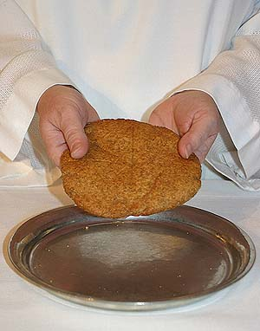
Sift dry ingredients together three times: (important!)
2 c whole wheat flour
1 c white flour
1 & 1/4 tsp baking powder
1 & 1/4 tsp salt
Stir in 4 tsp oil. Set aside.
Mix wet ingredients together until dissolved:
3/4 cup + 2 Tbsp very hot water (minimum of 180 degrees F)
3 Tbsp honey
3 Tbsp molasses
Add wet ingredients to dry ingredients and mix well. Dough should be slightly sticky. Do not knead.
Divide into four balls and flatten each into a 1/4 inch thick disk.
With a knife, score the top of each loaf into eight pie-shaped sections, so that the sections can be more easily broken off while serving. Alternatively, you could score a cross onto the loaf.
Lay the loaves on a baking sheet. Bake at 350 degrees for 10 minutes. Remove from oven and brush the tops of the loaves with oil. Bake an additional 5-8 minutes. Let cool.
Yield: four 8 oz. loaves. Each loaf serves 60-70 people, depending upon the size of the piece given. The loaves freeze well.

A well-used, well-loved recipe
Luther Seminary’s communion bread recipe has been used here for more than 25 years. It is baked by Luther Seminary dining services staff and served as part of our weekly Holy Communion service in chapel each Wednesday.
This recipe is known throughout the country as one of the best tasting and easiest to make. It’s become quite popular! In July 2012 Luther Seminary dining services staff baked an estimated 1,900 loaves and Fed-Ex-ed them to the ELCA’s youth gathering in New Orleans for their Sunday Eucharist!

