Stories Around the Table…

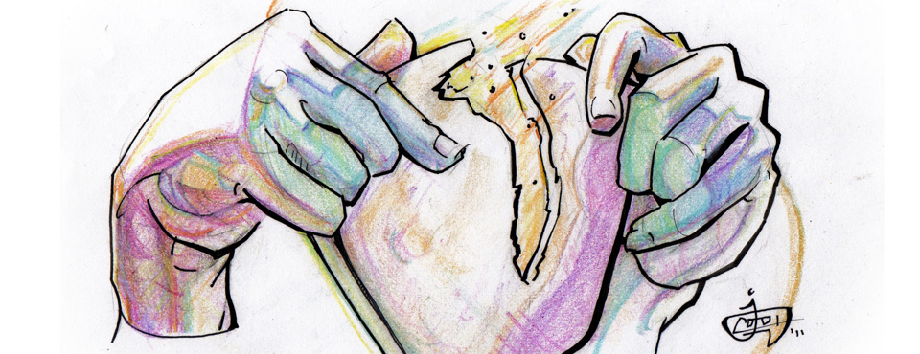

Lent 2020
Come to the table of mercy,
Prepared with the wine and the bread
All who are hungry and thirsty
Come and your souls will be fed.
Come at the Lord’s invitation
Receive from His nail scared hands
Taste of the bread of salvation
Drink from the cup of the Lamb

Lenten Service – April 1, 2020

December 2, 2018
Advent 1

4200 Vine Street
Lincoln, NE 68503-2818
(402) 466-6488

Email: amlutheran@alclincoln.com

Website: http://www.alclincoln.com

Follow us on Twitter: @amlutheran

Facebook: https://www.facebook.com/ALCLincoln

December 2, 2018
Advent 1

4200 Vine Street
Lincoln, NE 68503-2818
(402) 466-6488

Email: amlutheran@alclincoln.com

Website: http://www.alclincoln.com

Follow us on Twitter: @amlutheran

Facebook: https://www.facebook.com/ALCLincoln

Gathering Words…..

Service of Light…

As we sing together tonight, consider lighting a candle in your homes to remind you of the light of Christ that shines in the darkness and that no darkness can overcome.

Prayer:
May our prayers come before you O Lord as incense and may your presence surround and fill us so that in union with all creation, we might sing your praise and love in our lives. Amen.

“The Passover” - A Personal Reflection – Luke Worth

Reading: Exodus 12: 21-32
²¹Then Moses called all the elders of Israel and said to them, "Go, select lambs for your families, and slaughter the passover lamb. ²²Take a bunch of hyssop, dip it in the blood that is in the basin, and touch the lintel and the two doorposts with the blood in the basin. None of you shall go outside the door of your house until morning. ²³For the LORD will pass through to strike down the Egyptians; when he sees the blood on the lintel and on the two doorposts, the LORD will pass over that door and will not allow the destroyer to enter your houses to strike you down. ²⁴You shall observe this rite as a perpetual ordinance for you and your children. ²⁵When you come to the land that the LORD will give you, as he has promised, you shall keep this observance. ²⁶And when your children ask you, 'What do you mean by this observance?' ²⁷you shall say, 'It is the passover sacrifice to the LORD, for he passed over the houses of the Israelites in Egypt, when he struck down the Egyptians but spared our houses.'" And the people bowed down and worshiped. ²⁸The Israelites went and did just as the LORD had commanded Moses and Aaron. ²⁹At midnight the LORD struck down all the firstborn in the land of Egypt, from the firstborn of Pharaoh who sat on his throne to the firstborn of the prisoner who was in the dungeon, and all the firstborn of the livestock. ³⁰Pharaoh arose in the night, he and all his officials and all the Egyptians; and there was a loud cry in Egypt, for there was not a house without someone dead. ³¹Then he summoned Moses and Aaron in the night, and said, "Rise up, go away from my people, both you and the Israelites! Go, worship the LORD, as you said. ³²Take your flocks and your herds, as you said, and be gone. And bring a blessing on me too!"

“The Passover” – Dylan & Kalena Schuette

Prayer:
Good and gracious God, sometimes it is hard to wrap our minds around the stories of life and death that we see in scripture and in our world. Help us to continue to patiently trust in your love and mercy during these uncertain times..Lord, in your mercy. Hear our prayer.
Gracious Lord, you care for the oppressed and call us to see all people as brothers and sisters in Christ. Refresh our minds with the stories of our past and open our eyes and change are ways when we become the oppressors…Lord, in your mercy. Hear our prayer.
Send your saving help to all who suffer abuse, insult, discrimination, or contempt. Heal the wounded. Care for the unemployed and underemployed. Comfort the dying. Bring peace to those suffering from chronic or terminal illness…Lord, in your mercy. Hear our prayer.
The people of Israel found a new beginning through the blood of a lamb, we gather around Christ, the Lamb of God who takes away the sins of the world, restore all that is broken Lord, and open our hearts and spirits to the new life that blooms around us and reminds us that in Christ, fear, worry, sickness and death are never the end of the story. All these things we pray in the name of Christ. Amen.

Lord’s Prayer
Our Father in heaven, hallowed be your name, your kingdom come, your will be done, on earth as in heaven. Give us today our daily bread. Forgive us our sins as we forgive those who sin against us. Save us from the time of trial and deliver us from evil. For the kingdom, the power, and the glory are yours, now and forever. Amen.

Hymn “Bless Now, O God, the Journey”

Bless now, O God, the journey that all your people make,
The path through noise and silence, the way of give and take.
The trail is found in desert and winds the mountain round,
Then leads beside still waters, the road where faith is found.

Bless sojourners, and pilgrims who share this winding way;
Your hope burns through the terrors, your love sustains the day.
We yearn for holy freedom while often we are bound;
Together we are seeking the road where faith is found.

Divine eternal lover, you meet us on the road.
We wait for lands of promise where milk and honey flow,
But waiting not for places, you meet us all around.
Our covenant is written on roads, as faith is found.

